9. Guarantee obligations
The manufacturer guarantees the reliability of the operation of an individual LASERWAR set if the consumer has complied with the conditions of use. Technical support is provided within 12 months of the sale date. The manufacturer undertakes to replace or repair an individual set of equipment free of charge, if the customer has complied with the rules for the device transportation, storage, operation and delivery of defective equipment to Smolensk City.

10. Contact information
Official website:
www.laserwar.ru

E-mail:
info@laserwar.ru
support@laserwar.ru

Skype:
info-laserwar.ru
support laserwar.ru

_________________________

LIMITED
LIABILITY COMPANY
LASERTAG

SPECIFICATION
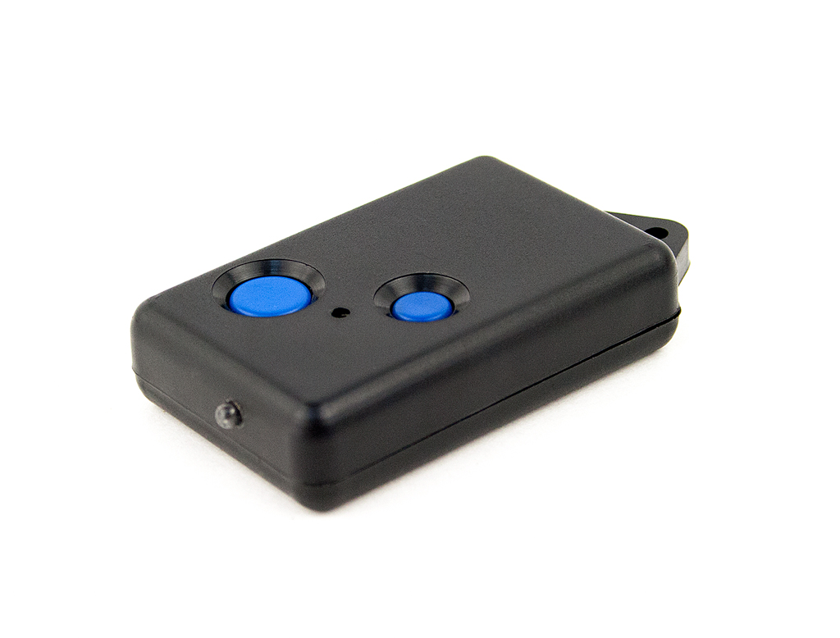

Game set
Nano remote control

Smolensk

1. Description
Nano remote control has two buttons that help to use laser tag equipment during the game.

2. Scope of application
The device is designed for laser tag weapons remote control and is used in organizing sporting events, tactical exercises, corporate and recreational activities.
3. The set includes:
- Nano remote control - 1 pc.
- Specification - 1 pc.

4. Basic technical Data
Length, mm | 57
Width, mm | 37
Thickness, mm | 15
Voltage | 3
Weight, gr | 22

5. Device
The device has a plastic frame of black color.
Inside the frame there is a battery, control junctions, mounting hardware. The frame has infrared emitters, LED, and two control buttons.
6. Maintenance
All parts of the set must be treated with care if you want the equipment to function properly. Avoid dirt contamination and damage to IR emitters. There shouldn't be any moisture inside the frame. Change the batteries when needed. Don't hit the device.
7. User's manual
Basic device options "New Game" and "End game." If you press one of those buttons, a red LES will light up.

- "New Game" button
- LED
- "End Game" button
- IR-diode

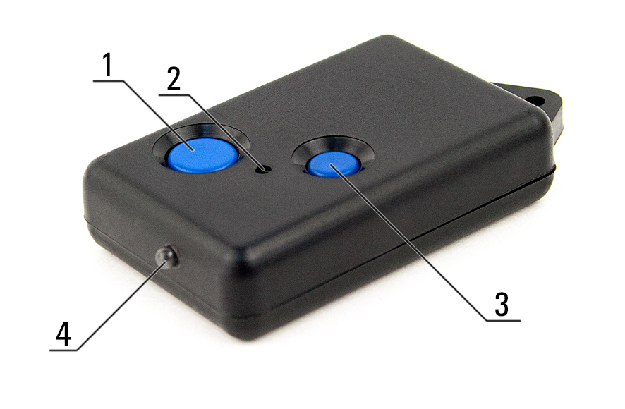

8. Changing the device settings.

Device settings change is not supported.

